# ST.XAVIER’S COLLEGE

# MAITIGHAR, KATHMANDU



**ASSIGNMENT ON**

**Database Management System**

**Submitted By:**

Shaurabh Chapagain

013BSCCSIT037

**Submitted To:**

Er. Sanjay Kumar Yadav

Lecturer

Department of Computer Science

St. Xavier’s College

**Data recovery**

Data recovery is the process of restoring data that has been lost, accidentally deleted, corrupted or made inaccessible for any reason.

**Purpose of Data recovery**

The purpose of a database strategy is to protect the database against data loss and reconstruct the database after data loss, which can be listed as follow:

* Planning and testing responses to different kinds of failures
* Configuring the database environment for backup and recovery
* Setting up a backup schedule
* Monitoring the backup and recovery environment
* Troubleshooting backup problems
* Recovering from data loss if the need arises

**Types of Failure**

System failure can be classified into following types:

**Transaction failure**

A transaction has to abort when it fails to execute or when it reaches a point from where it can’t go any further which is called transaction failure. Reasons for a transaction failure could be as follow:

* **Logical error**s: Where a transaction cannot complete because it has some code error or any internal error condition.
* **System errors**: Where the database system itself terminates an active transaction because the DBMS is not able to execute it, or it has to stop because of some system condition. For example, in case of deadlock or resource unavailability, the system aborts an active transaction.

**System Crash**

There are problems − external to the system − that may cause the system to stop abruptly and cause the system to crash. For example, interruptions in power supply may cause the failure of underlying hardware or software failure. Examples may include operating system errors.

**Disk Failure**

In early days of technology evolution, it was a common problem where hard-disk drives or storage drives used to fail frequently.

Disk failures include formation of bad sectors, unreachability to the disk, disk head crash or any other failure, which destroys all or a part of disk storage.

**The Storage Hierarchy**

Databases are stored in file formats, which contain records. At physical level, the actual data is stored in electromagnetic format on some device. These storage devices can be broadly categorized into three types:

* **Primary Storage** − Memory storage that is directly accessible to the CPU comes under this category. CPU's internal memory (registers), fast memory (cache), and main memory (RAM) are directly accessible to the CPU, as they are all placed on the motherboard or CPU chipset. This storage is typically very small, ultra-fast, and volatile. Primary storage requires continuous power supply in order to maintain its state. In case of a power failure, all its data is lost.
* **Secondary Storage** − Secondary storage devices are used to store data for future use or as backup. Secondary storage includes memory devices that are not a part of the CPU chipset or motherboard, for example, magnetic disks, optical disks (DVD, CD, etc.), hard disks, flash drives, and magnetic tapes.
* **Tertiary Storage** − Tertiary storage is used to store huge volumes of data. Since such storage devices are external to the computer system, they are the slowest in speed. These storage devices are mostly used to take the back up of an entire system. Optical disks and magnetic tapes are widely used as tertiary storage.

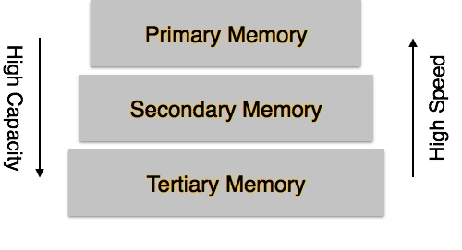

* **Volatile storage** − Volatile storage cannot survive system crashes. Volatile storage devices are placed very close to the CPU; normally they are embedded onto the chipset itself. For example, main memory and cache memory are examples of volatile storage. They are fast but can store only a small amount of information.
* **Non-volatile storage** − Memories are made to survive system crashes. They are huge in data storage capacity, but slower in accessibility. Examples may include hard-disks, magnetic tapes, flash memory, and non-volatile (battery backed up) RAM.

**Buffer Management**

Buffer management is a key component in achieving this efficiency. The buffer management component consists of two mechanisms: the buffer manager to access and update database pages, and the buffer cache (also called the buffer pool), to reduce database file I/O.

**Transaction log**

**Data updates**

**Data caching**

**Transaction Roll back (Undo) and Roll forward**

**Check pointing, shadow paging**

**Recovery schemes (WAL: Write Ahead Logging protocol)**

**Failure with loss of Non-volatile storage (General concept)**

**Recovery in multi-database system**